
Test Case
Laser Pointing to a Safe
Passage Condition
Robotic Cognition System for Wheelchair
Unicamp

Table of Contents
1 Purpose of this Document 3
2 Test case C: Laser pointing to a safe passage condition 4

Document Information
Project Name: | Robotic Cognition System for Wheelchairs
Prepared By: | Tarcisio Franco de Carvalho | Document Version No: | 1.0
Title: | Test case C – Laser pointing to a safe passage condition | Document Version Date: | 24/Jun/20
Reviewed By: |  | Review Date:
Distribution List
From | Date | Phone/Fax/Email

Acronyms
Acronym | Description
UPD | Unevenness Point Data

Document Version History
Version  Number | Version  Date | Revised By | Description
1.0 | 24/Jun/2020 | Tarcisio Franco | Initial Version

Purpose of this Document
Define and document the test cases related to the robot cognition system solution for wheelchair.

Test case C: Laser pointing to a safe passage condition

This test case will verify if the passage condition classifier is classifying as safe when the laser is pointing to green point clouds on UPD.

Entry criteria
- Gazebo up and running the simple_blocks.world configuration
- Gazebo up and running the sim_model.urdf.xacro related to the wheelchair robot components
- Python web server up and running the web_app.py script
- Rviz up and running
- UPD processing component up and running
- Laser sensor data to point cloud parser component up and running
- Classify passage condition component up and running

Exit criteria
- Move the laser direction to a green point cloud region showed in Rviz. The Web UI control should show a green block with the “safe passage condition message”

Test execution and results

- Start Gazebo environment simulation
On the project root folder, run the script ./sim_model/scripts/launch.sh it will process the simple_blocks.world and sim_model.urdf.xacro files

Result
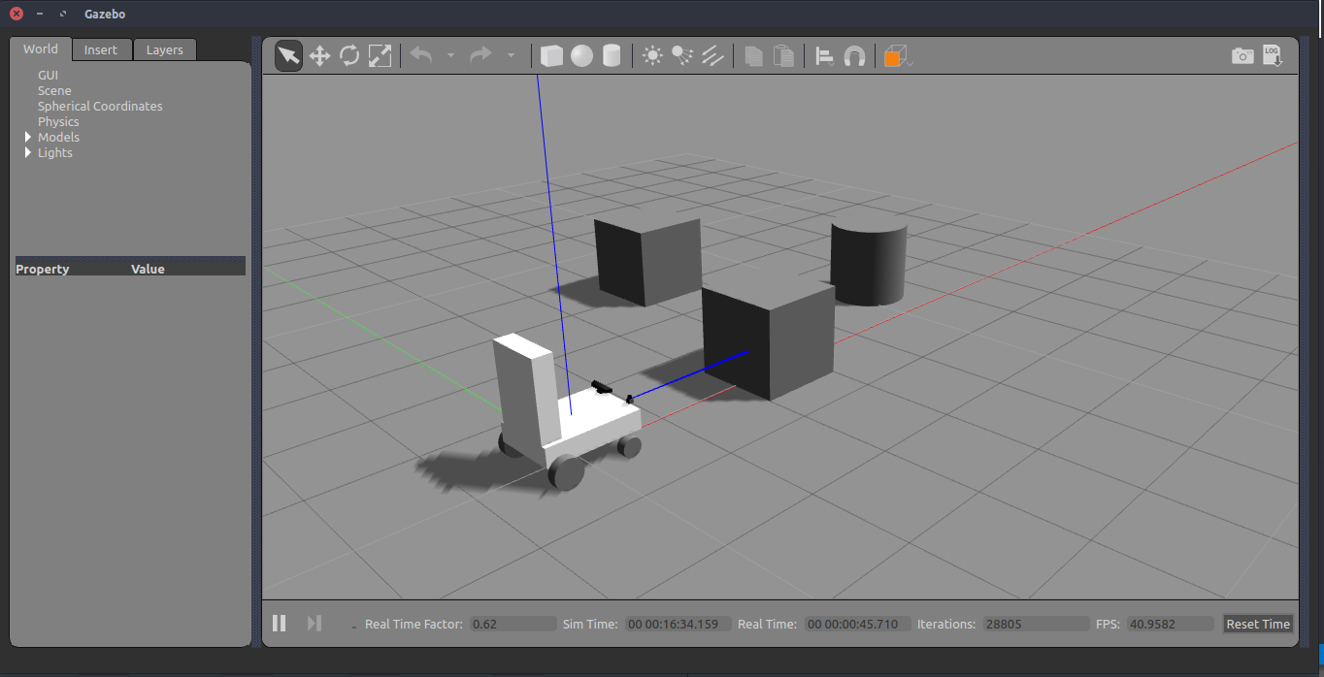

- Start web user interface to control the laser

On the project root folder, run the script python src/web_app.py it will start the flask web server and a web page where the laser can be controlled. After starting, in a web browser open the http://localhost:8080

Result
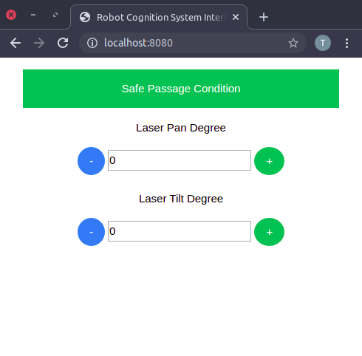

- Start the laser sensor data to point cloud parser component

On the project root folder, run the script python src/laser_publisher.py it will start a node to published parsed laser data.

Result
Passed. In the Rviz the red points are the parsed laser data
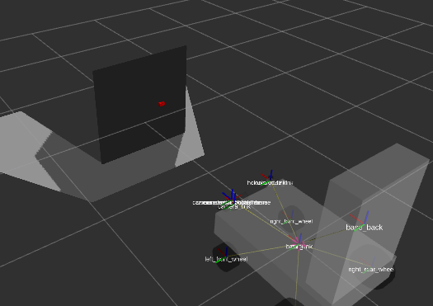

- Start the UPD processing component

On the project root folder, run the script ./upd_run.sh it will start a node to published UPD data

Result
Passed. In Rviz the UPD data is being showing.

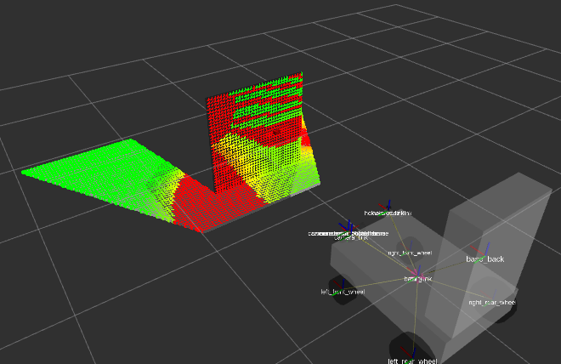

- Start the Classify passage condition component

On the project root folder, run the script ./classifier_run.sh it will start a node to publish passage condition classified data

Result
Passed.
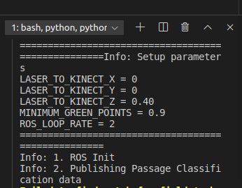

- Move the laser direction to a safe passage condition
In the UI, move the laser pan and tilt to reach green UPD classified points cloud in Rviz, then verify if the box message color in UI will change to green.

Result
Passed

- Before
Simulation | Rviz | UI
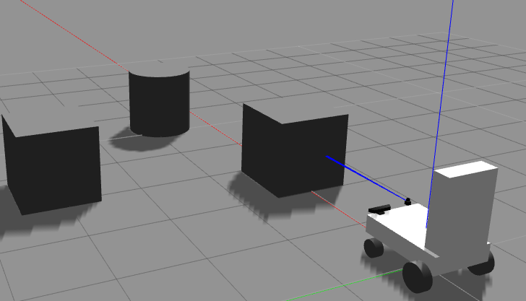
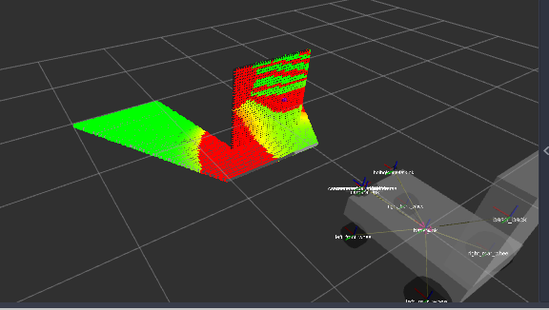
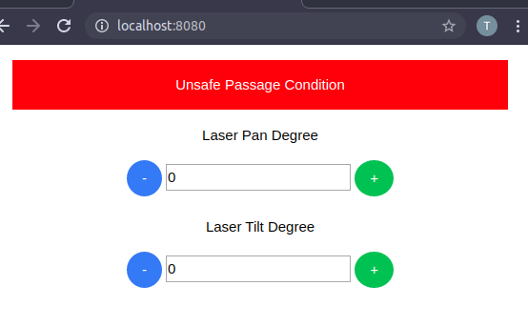

- After
Simulation | Rviz | UI
